Pumpkin Squares

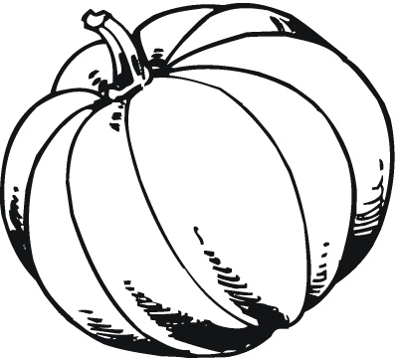
Ingredients
- 4 eggs, beaten
- 1 15-ounce can pumpkin
- 1 1/3 cups sugar
- 1 cup vegetable oil
- 2 cups flour
- 2 teaspoons baking powder
- 1 teaspoon baking soda
- 1 teaspoon salt
- 2 teaspoons cinnamon
- 1/4 teaspoon ginger or nutmeg
Frosting
- 1 3-ounce package cream cheese, softened
- 1/4 cup butter
- 3/4 teaspoon vanilla extract
- 2 cups confectioners' sugar

Instructions
- Heat the oven to 350 degrees. Beat together the eggs, pumpkin, sugar and oil until well blended. Add the flour, baking powder, baking soda, salt, cinnamon, and the ginger or nutmeg. Mix until smooth, then spread the batter in an ungreased 10- by 15-inch baking pan (or, for a fluffier version, a 9- by 13-inch pan). Bake for 25 to 35 minutes, or until a toothpick inserted into the center comes out clean. Allow to cool.
- For the frosting, beat together the cream cheese, butter, and vanilla extract until light and fluffy. Add the confectioners' sugar and beat until smooth. Spread the frosting over the cake, then cut into 24 squares.

